Brainstorm

& idea prioritization

Before you collaborate

A little bit of preparation goes a long way with this session. Here’s what you need to do to get going.

10 minutes

Team gathering Objective:
A
To bring the team together to identify a real organizational problem and agree on a project that
1

Define your problem statement

Employees in the organization need a quick and efficient way to request laptops for work. The current process is manual and prone to delays, with no dynamic form behavior to guide users or ensure accurate data collection. To address this, a Service Catalog item needs to be created, allowing users to easily request a laptop, with dynamic fields, clear instructions, and additional functionality like resetting the form if needed. The solution should also ensure all changes are tracked for governance and deployment. in service now
2

PROBLEM
Inefficient manual laptop requests; need automated dynamic ServiceNow catalog

Brainstorm

Write down any ideas that come to mind that address your problem statement.

10 minutes

Person 1
Automate Implement

Person 2

Include

TIP
You can select a sticky note and hit the pencil [switch to sketch] icon to start drawing!

Display only

Use this template in your own brainstorming sessions so your team can unleash their imagination and start shaping concepts even if you're not sitting in the same room.

Date : 31 October 2025
Team Id: 604C33E48F0DC12A3894968A103C70F4
Project Name: Laptop Request Catalog Item
improves efficiency using ServiceNow.

Set the goal
B
To design and implement a ServiceNow Service Catalog Item that enables employees to quickly and accurately request laptops with dynamic fields, automated approvals, and complete tracking — improving efficiency and user satisfaction.
C

Specific Objectives
Automation: Replace manual email-based laptop requests with a fully automated ServiceNow process. Dynamic Form Behavior: Display relevant fields based on user input (e.g., show justification if a high-end laptop is selected).
Accuracy: Ensure required details like laptop model, duration, and business justification are properly captured. Reset Functionality: Allow users to reset and re-enter data easily without reloading the form.
Approval Workflow: Automatically route requests to the appropriate manager for approval.
Tracking & Audit: Maintain logs of requests and changes for governance and transparency.
User Experience: Provide a clean, guided interface that minimizes confusion and incomplete submissions.

solution.

To design and implement a ServiceNow Service Catalog Item that enables employees to quickly and accurately request laptops with dynamic fields, automated approvals, and complete tracking — improving efficiency and user satisfaction.
laptop request process in ServiceNow.

Person 3

Simplify form layout to reduce errors.
dynamic form behavior using UI Policies.

Ensure compliance with IT governance policies.
approval workflow for managers

Person 4

Improve accuracy of collected data.
relevant fields for
each request.

Missing or incomplete request information.


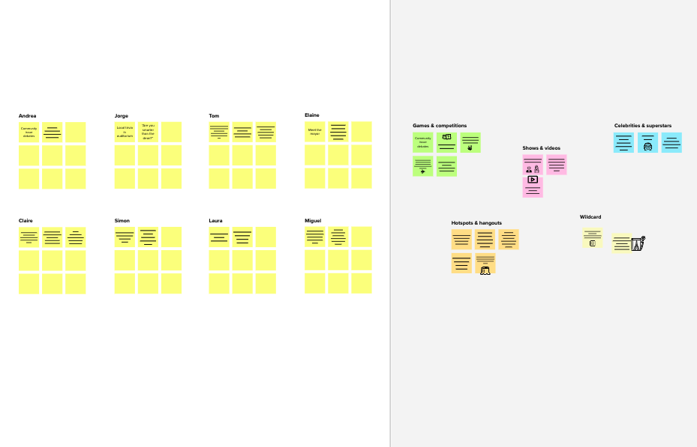






Template

Need some inspiration?
See a finished version of this template to kickstart your work.

Open example

